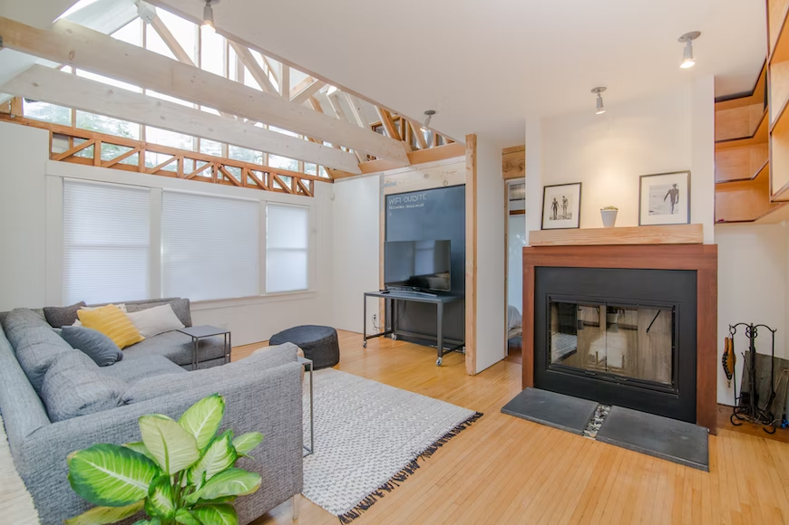
Source - Unsplash

Tips for Empty Nesters That Want to Make the Most Out of Life

Many parents find it to be very bittersweet when their children grow up and leave the house. While it is nice to have some peace and quiet, there is a tendency to get bored and miss the days when your kids used to keep you busy. The good news is that you can live your best life even after your children have moved on and left the house. Here at Elko Senior Center, we love to help empty nesters feel happy as they enjoy their golden years, so we have some tips for how you can make the most of this second phase of your life.

Start a Business With an LLC

If you have always had a great idea for a company but you never had the time, then it may be the moment you have been waiting for. Starting a business is a great idea because you won’t be distracted by the kids, and you can really focus on your most important tasks. If you want to relax more in your later years, then consider starting a business from home. You could do anything from online tutoring to selling products on a website.

Whatever you do, it is important that you make your business official, and you can do that by forming your company as a limited liability corporation. An LLC is great for first-time entrepreneurs because it offers a lot more flexibility, and there is less paperwork to bog you down. When creating your LLC, it is important that you meet the guidelines of your state. If you need help in this area then you can save money and avoid hefty lawyer fees by hiring a formation service to assist.

You Can Also Earn a Degree and Start a New Career

If you are not interested in starting a business then you can instead consider a return to school where you can earn a degree and start a new career. There are many different fields that you can get into even later in life. Accounting, business administration, and web design are all great majors that are easy to get into, and you can use them to make money in your later years.

If you don’t think that you have the time to return to school then this may help. It is the option to get your bachelor's degree in education at an online school. Teaching is another great field because you can impart your wisdom to others, and it can be incredibly rewarding. Best of all, you can attend classes during nights and weekends so you can still enjoy your time at home or stay at your current job.

This Is a Good Time to Declutter and Organize Your PDF Files

The first step that you should take when your kids leave the house is to declutter and remove the items that you no longer need. Clean out the closets and ask your kids which clothes they want to keep and which can be donated. You should also look through your garage and remove any items you no longer need.

This is also a good time to get rid of the mass amounts of paperwork that you have floating around your house. You can easily scan all of those documents into your computer. It is important to be organized during this process. Every file should have its own folder. If you have large PDF files that contain many files, then look online for a PDF splitter tool that will allow you to separate what you need from the file so you can put it where it needs to go. Many people prefer PDFs because they are easy to download and share.

As you can see, there are many different roads that you can take once you become empty nesters. Consider the idea of starting your own company, returning to school for an online degree, and taking time to declutter, and you will find purpose in your later years. If you would like to learn more about the services at Elko Senior Center, then contact us at 775-738-3030.

